***Project Phase IV Report***

***On­­­***

**Food’s Code (Restaurant Website)**

**Submitted for the requirement of**

**Project course**

BACHELOR OF ENGINEERING

**COMPUTER SCIENCE & ENGINEERING**



**Submitted to: Submitted By:**

Project Teacher (Supervisor) Shivam Raj (20BCS2386)

Er. Deepika(11809) Ananya Jain (20BCS2444)

 Arkesh Bhargava (20BCS2429)

Shivam Khanna (20BCS2401)

**Co Supervisor Signature**

(Gagan Mala)



**DEPARTMENT OF COMPUTER SCIENCE & ENGINEERING**

**CHANDIGARH UNIVERSITY, GHARUAN**

**June 2022**

### 

**ABSTRACT**

This report is conducted in order to set the foundations upon which the final project will take place. The title of the project is: “Food’s Code”.

The main target of this report is to conduct a thorough and in-depth analysis of the vast field of Software engineering and at the same time explore the opportunities and the conditions that could lead into building a successful website. The simplicity and ease of access of a menu are the main things that facilitate ordering food in a restaurant. A menu completely revolutionizes the patron’s dining experience. Existing programs provide an app that restaurants can use to feed their menus into websites and make it easier for the diners to flip, swipe & tap through the menu.

The purpose of this website is to automate the existing manual system to help the computerized equipment and full-fledged computer software, fulfilling their requirements, so that their valuable data/information can be stored for a longer period with easy accessing and manipulation of the same. The required software and hardware are easily available and easy to work with.

We here aim to provide the restaurants with a website menu that would recommend dishes based on a recommendation algorithm which has not been implemented elsewhere. We use a MY SQL server for storing the database which makes it inexpensive & secure. For User Interface we use HTML, CSS and JS for making our website attractive and responsive.

**TABLE OF CONTENT**

|  |  |  |
| --- | --- | --- |
| Sr no. | Topic | Page No. |
| 1 | Use of Modern tools in design and analysis | 4 |
| 2 | Discussion and report/results analysis | 6 |
| 3 | Project management and Professional communication (Presentation) | 7 |
| 4 | Attainment of stated outcomes | 19 |

|  |  |  |  |
| --- | --- | --- | --- |
| References | |  |  |
|  | | |  |
|  | | |  |
|  | |  |  |
|  | |  |  |
|  |  | |  |

**Chapter – 1**

**USE OF MODERN TOOLS IN DESIGN AND ANALYSIS**

The name ‘Food’s Code’ suggests that this is an restraunt website. So we use many programming languages like HTML, CSS, JS, PHP, My SQL, and many more. To handle these languages we use entire initial tools that we need for making any website.

There are the following tools that we need in design and analysis of the website:

**Hardware requirements:**

* Dual-core64-bitprocessor.
* Upto4GBofmemory.
* Upto4GB of internal storage Android SDK: 2GB
* Windows SDK: 4GB.
* Network interface card
* External Hard Drive

**Software tools:**

* VS Code:

Visual Studio Code is a streamlined code editor with support for development operations like debugging, task running, and version control. It aims to provide just the tools a developer needs for a quick code-build-debug cycle and leaves more complex workflows to fuller featured IDEs, such as Visual Studio IDE.

* My SQL:

MySQL is an open-source relational database management system. Its name is combinations of “My”, the name of co-founder Michael Widenius's daughter, and "SQL", the abbreviation for Structured Query Language. In Dark Town Cafe this use for making the database of the whole website

* XAAMP Server:

XAMPP helps a local host or server to test its website and clients via computers and laptops before releasing it to the main server. It is a platform that furnishes a suitable environment to test and verify the working of projects based on Apache, Perl, MySQL database, and PHP through the system of the host itself.

* Tawk.to:

Tawk.to is a site that provides chat bot to Dark Town Cafe. This provides live chat as well as inbuilt chats to the users. Which helps the clients if they face any problem in operating the website?

* Pinterest:

Pinterest is a social site where you can collect and share images of anything you find interesting. You can also visually discover new interests by browsing the collections of other [Pinterest users](https://www.lifewire.com/most-popular-pinterest-users-to-follow-3485976). We use this site for collecting all the images for Dark Town Cafe.

* Sublime text:

Sublime Text is a shareware cross-platform source code editor. It natively supports many programming languages and markup languages. Users can expand its functionality with plug-in, typically community-built and maintained under free-software licenses. To facilitate plug-ins, Sublime Text features a Python API. The whole Dark Town Cafe website phages are done in the sublime text editor. This is an advanced editor which mainly helps in making HTML, CSS, JS, PHP files.

**Chapter – 2**

**DISCUSSION AND REPORT/RESULTS ANALYSIS**

Now if we compare the Food’s Code system with already existing systems like other restraint website both are mostly similar with only some minor’s changes you find on the both websites. Both systems have the same functionality or same purpose of making the site work in the digital world and interact with people online. Because everyone has a hectic schedule of life and also they want to live with technology, this is the reason people more go toward online systems instead of going to a particular place and spend their precious time. Well, come on the point if we talk about the difference between Food’s Code and others existing systems. The main difference is that Food’s Code website is designed for individual restraunt for selling food products in a particular area but others like Swiggy software is for over India. Food’s Code is designed using modern tools and with attractive UI/UX designs. The website provides an interesting, interactive and user friendly look if a new user comes he or she can easily interact with the site. We also provide a chatbot option to users if they can face any problem they can connect to. Food’s Code also provides get in touch form at the user side. If anyone wants to connect he or she can fill the form our team can connect to the person within 24hrs.

**Chapter – 3**

**PROJECT MANAGEMENT AND PROFESSIONAL COMMUNICATION**

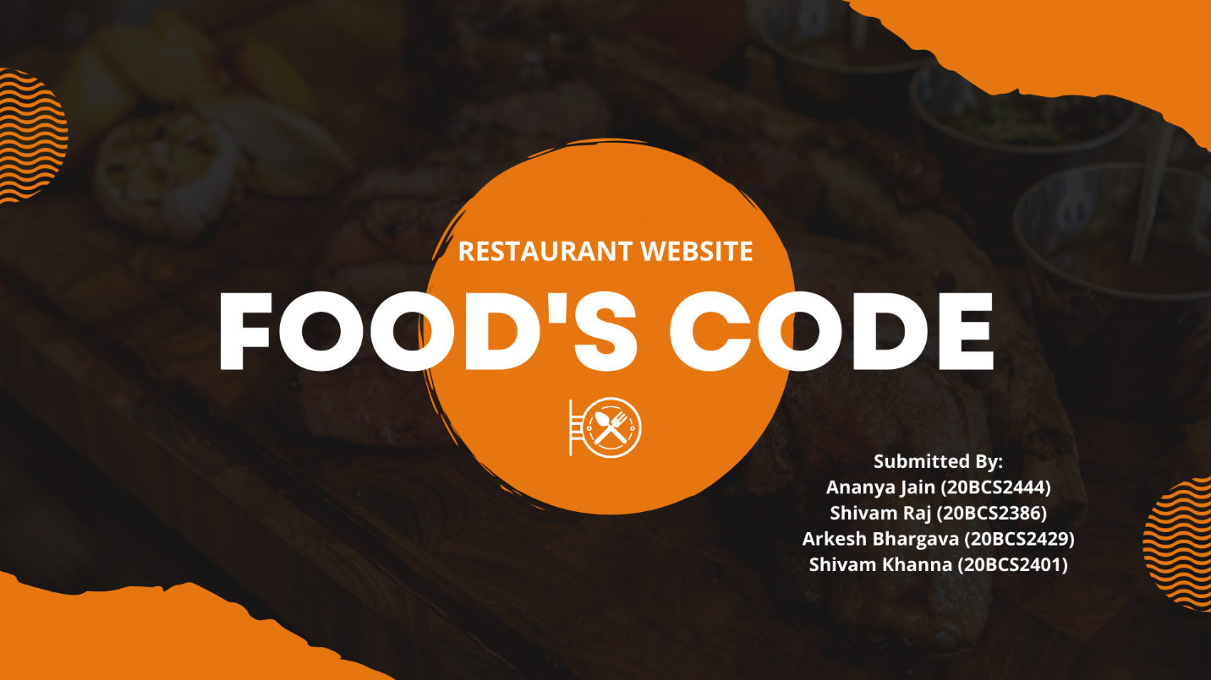

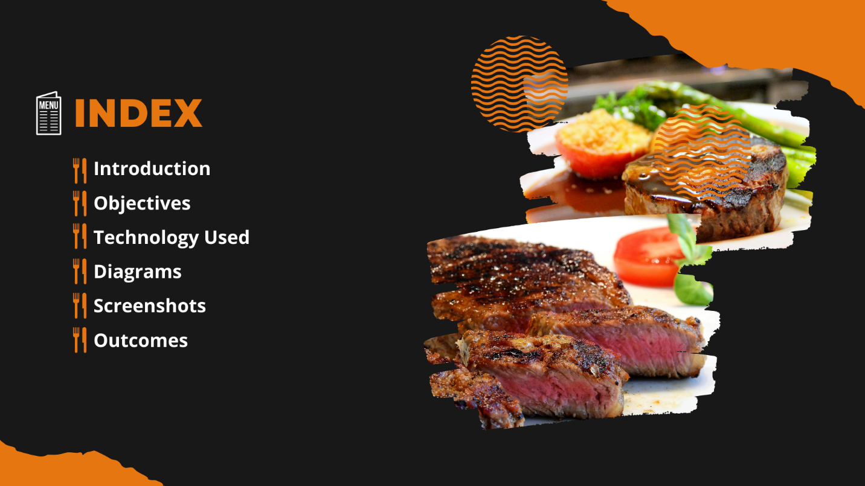

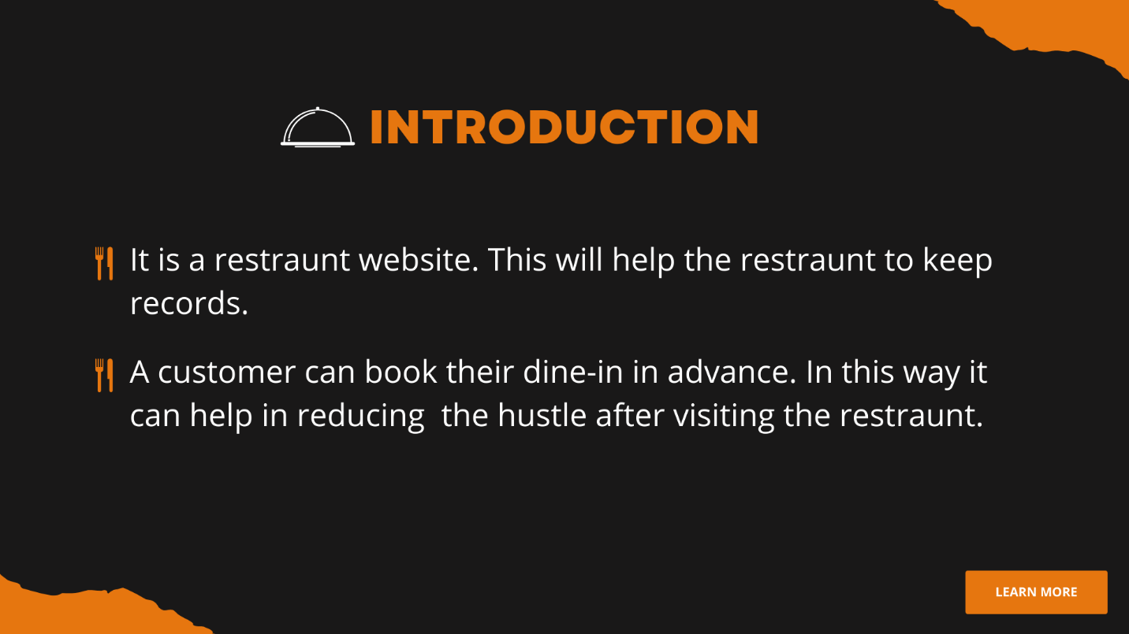

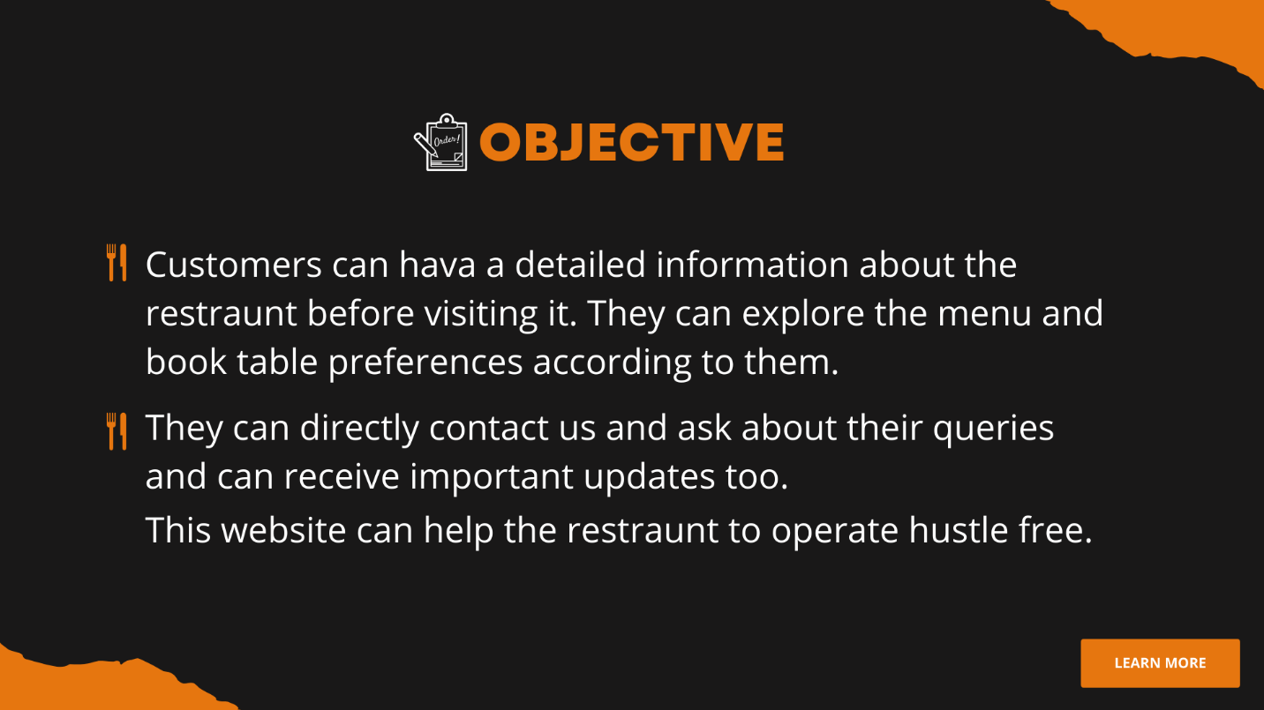

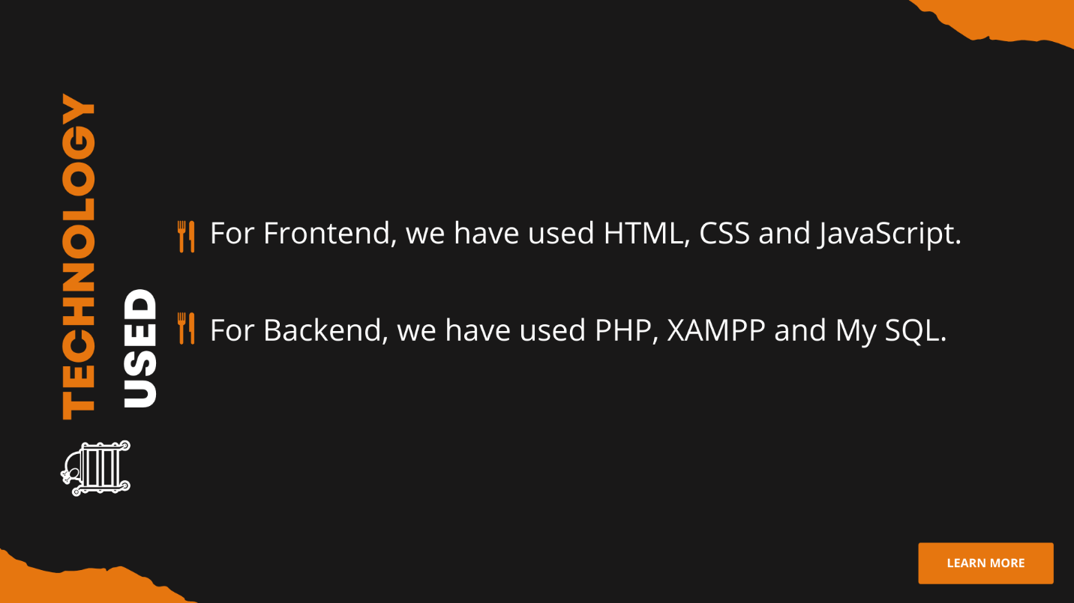

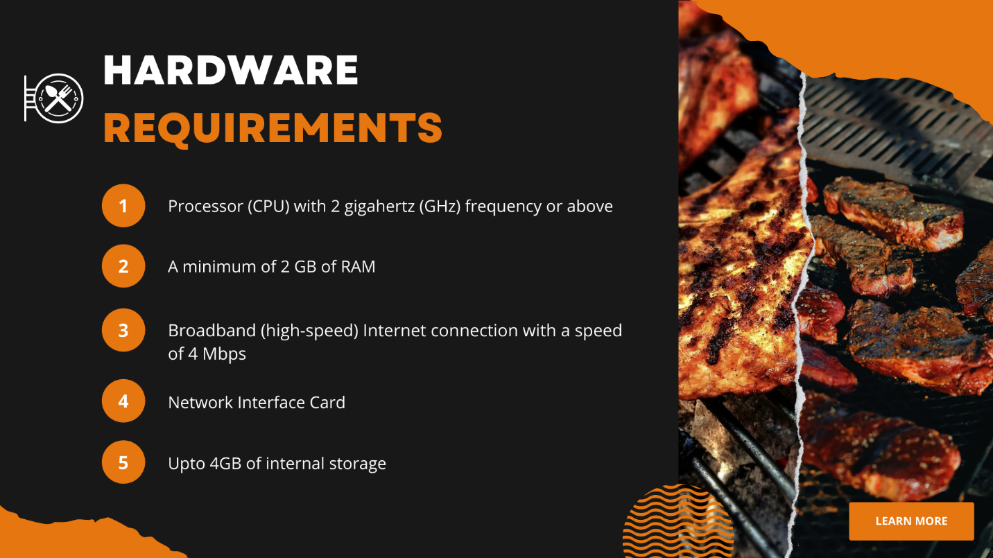

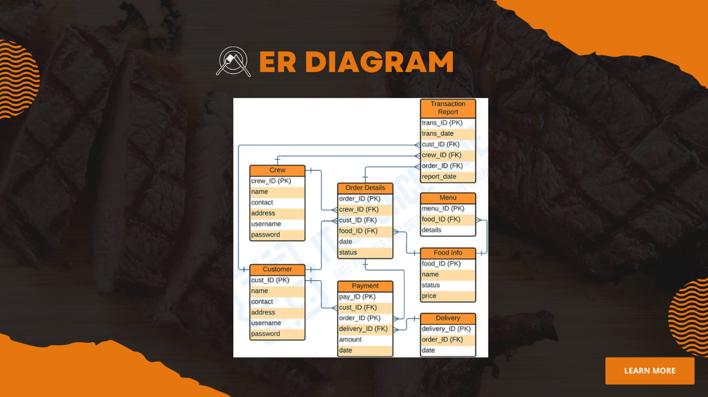

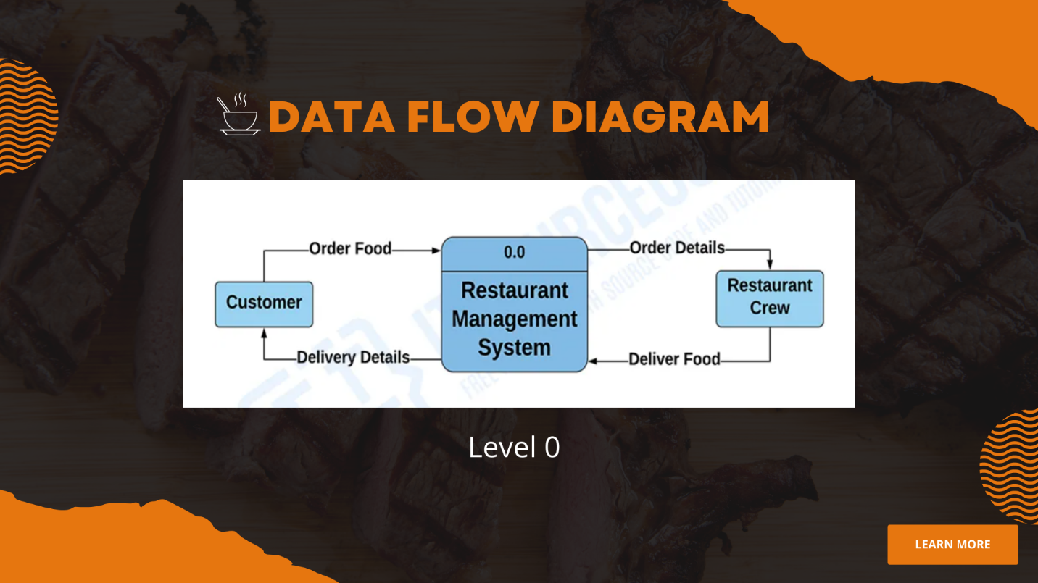

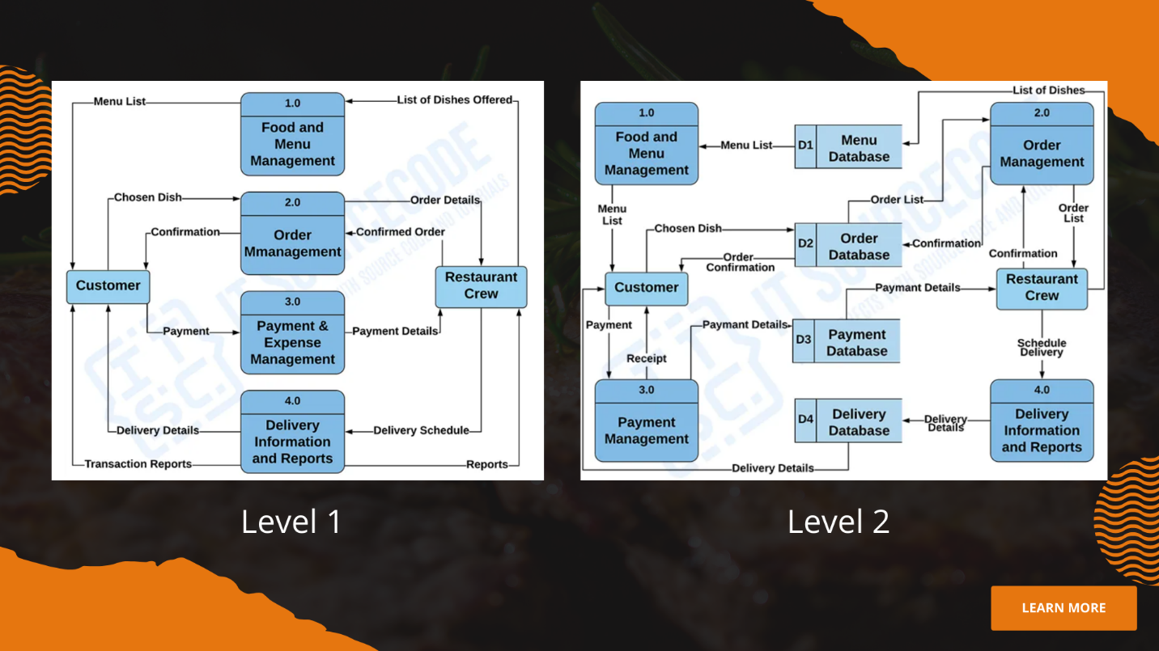

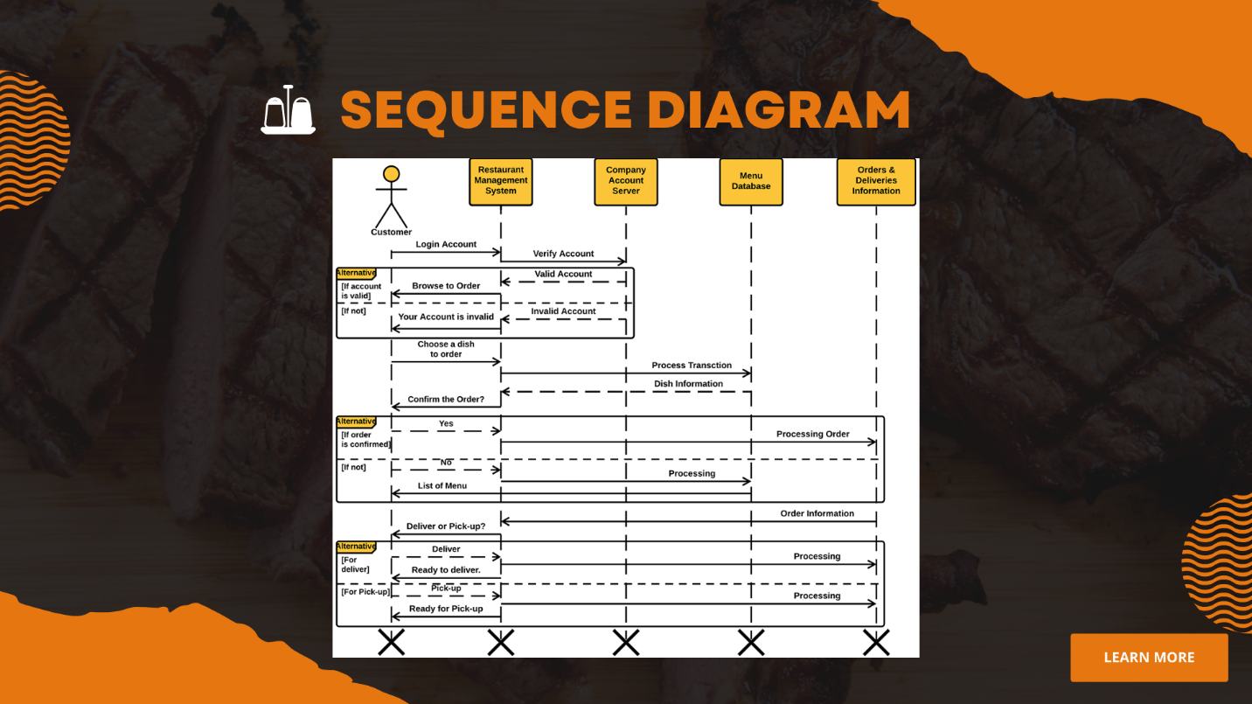

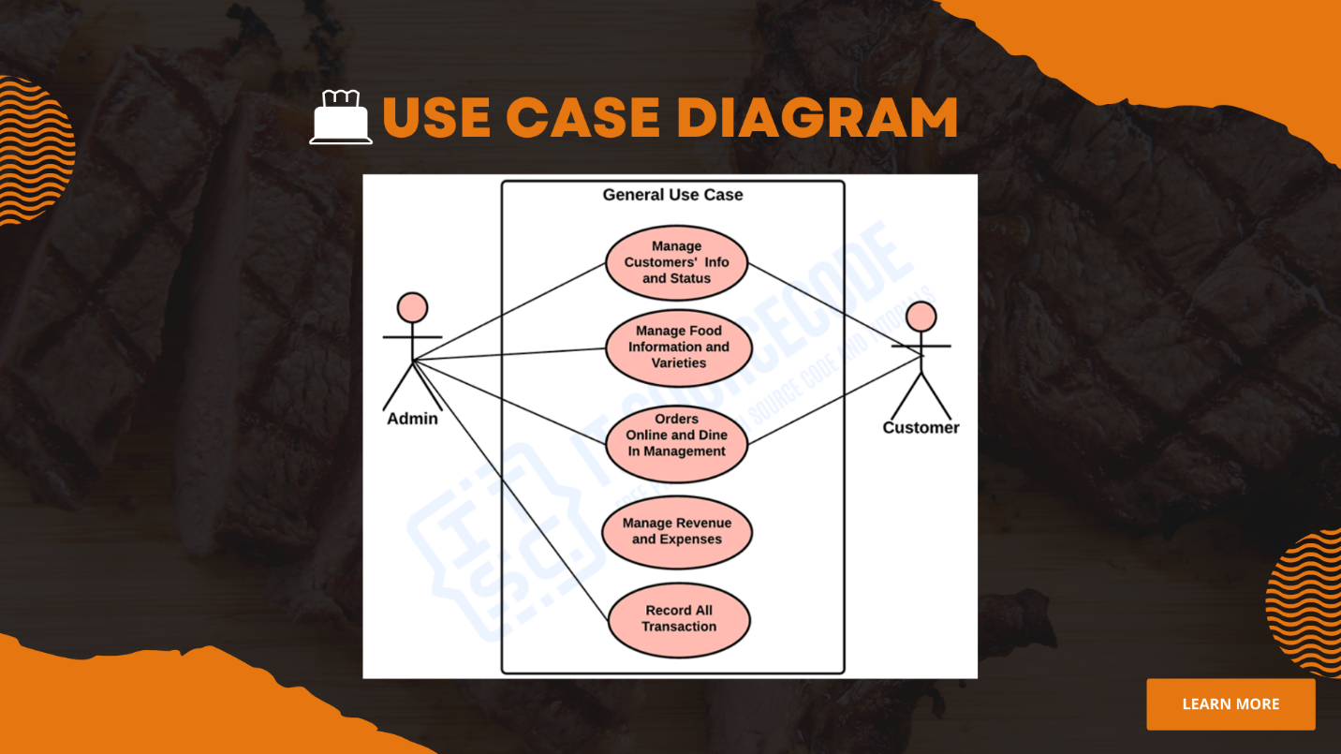

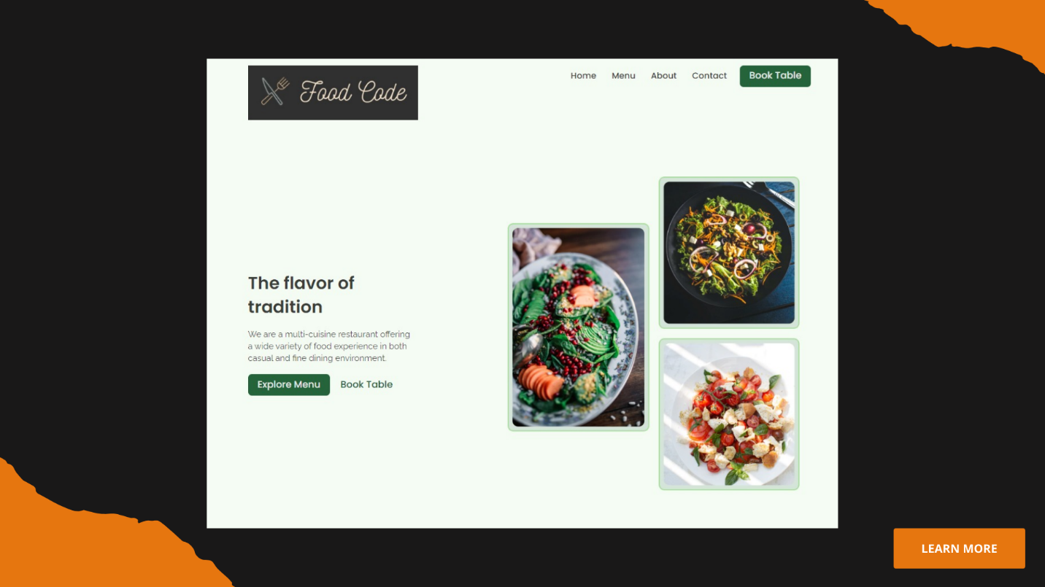

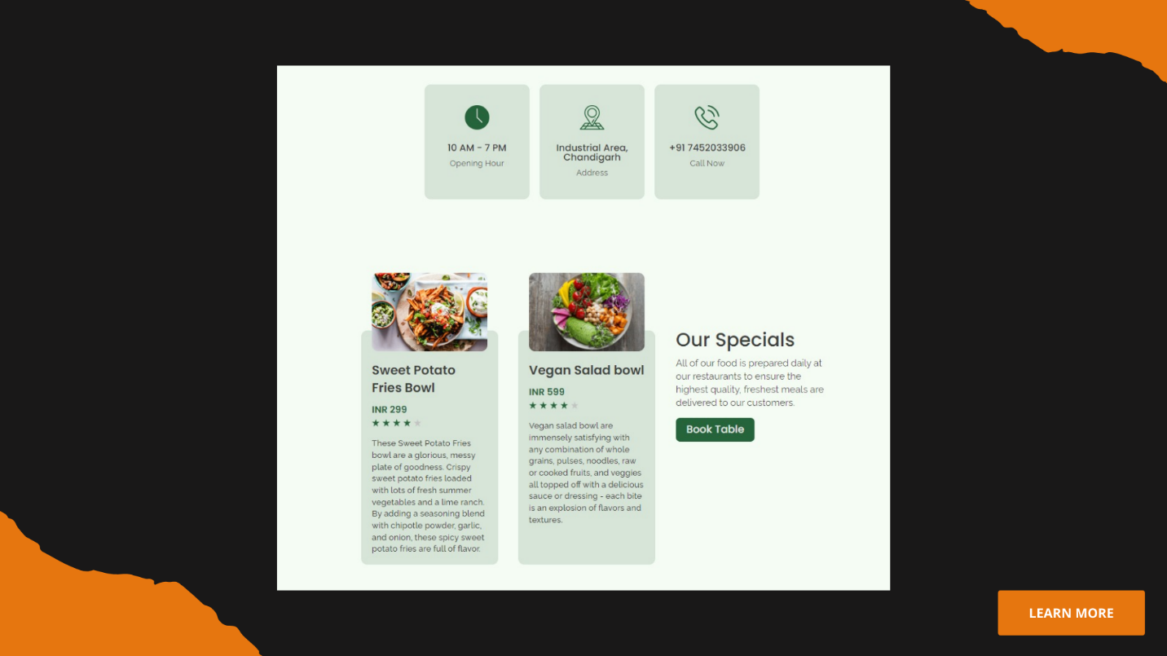

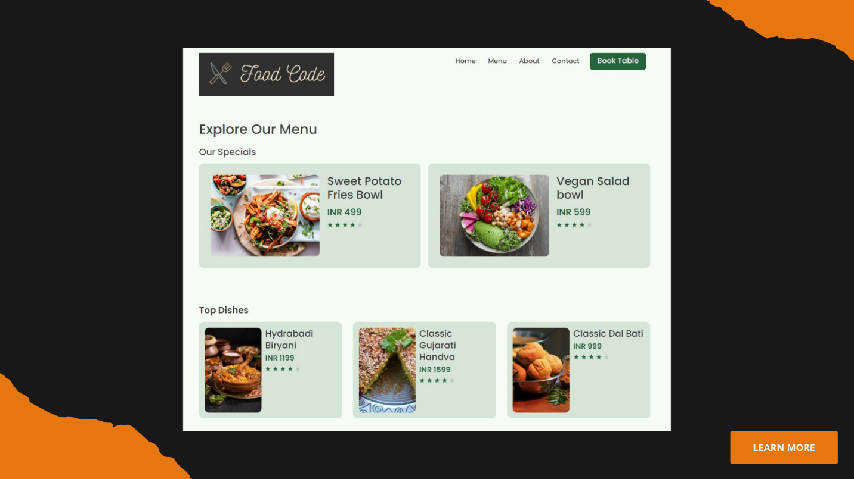

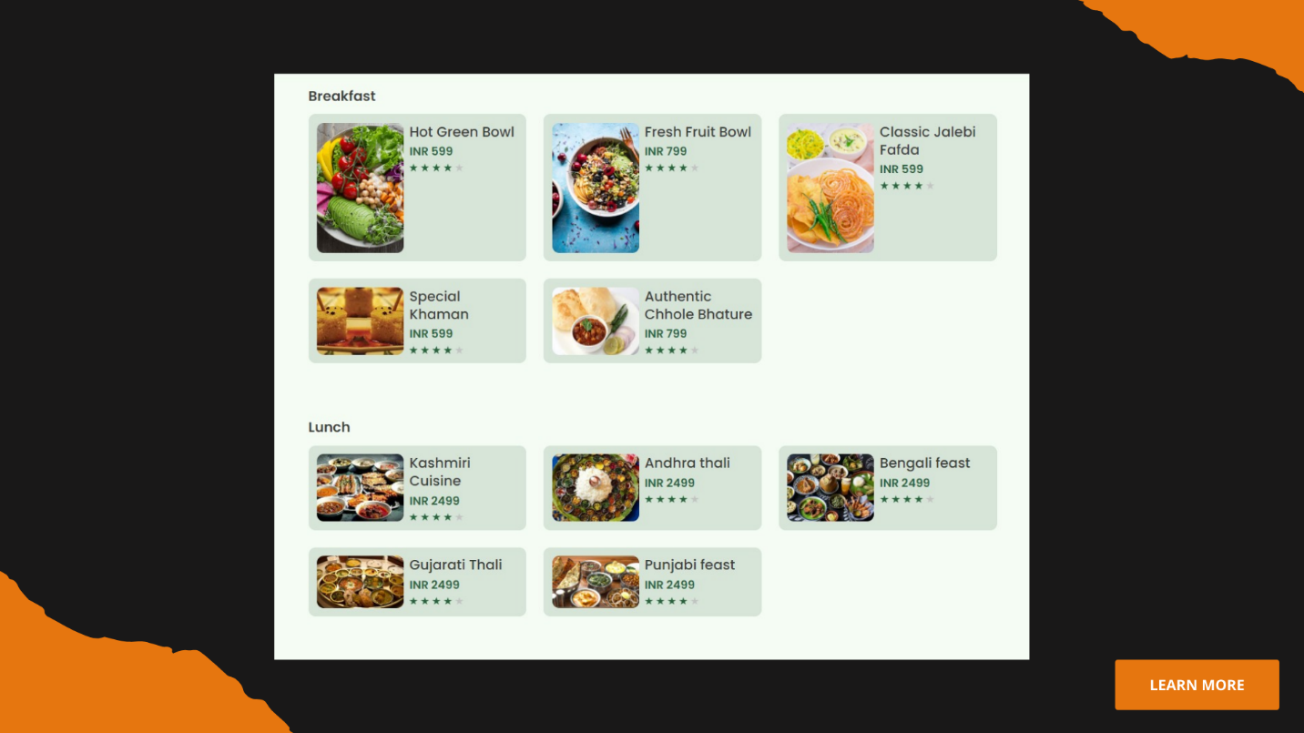

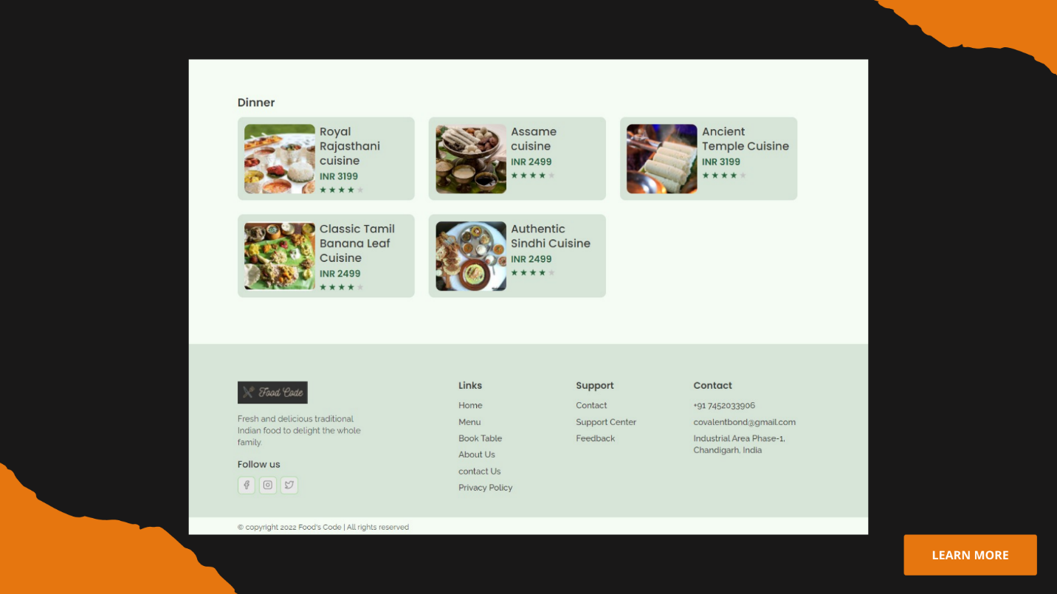

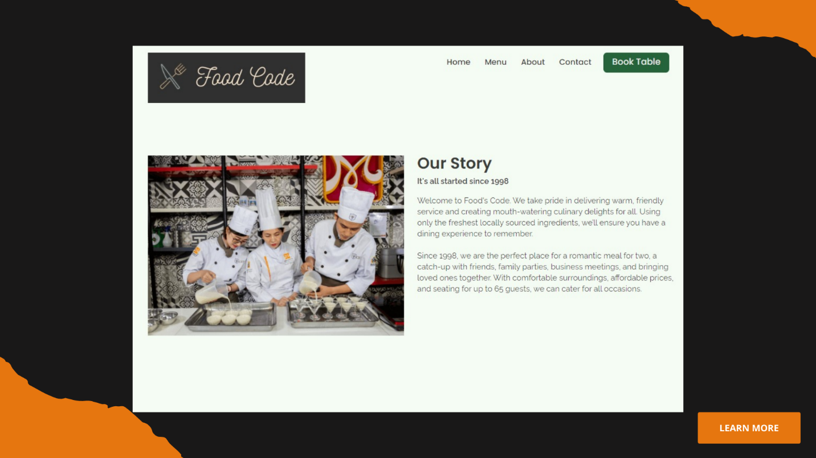

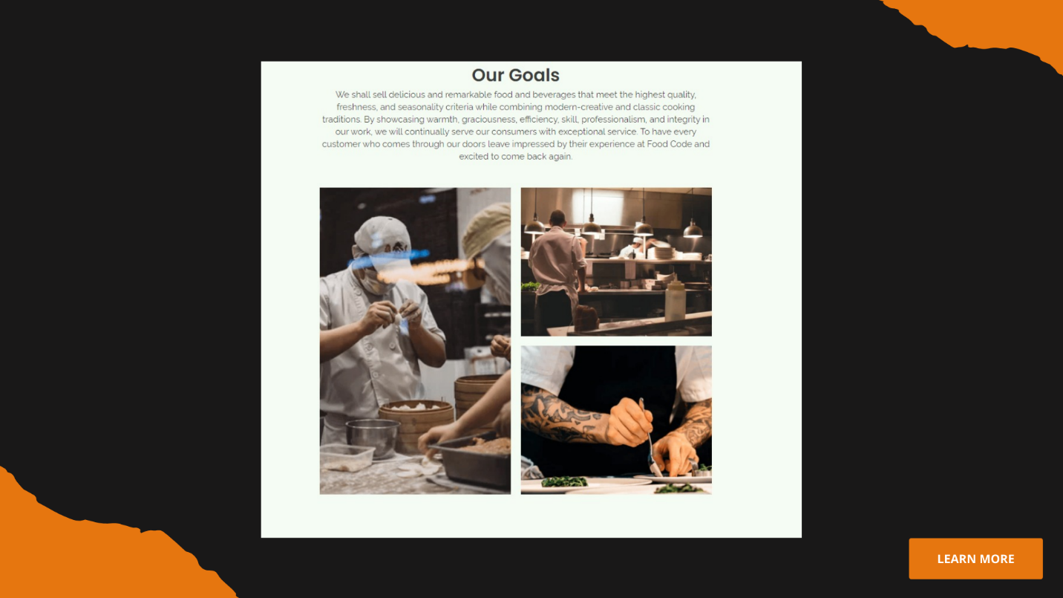

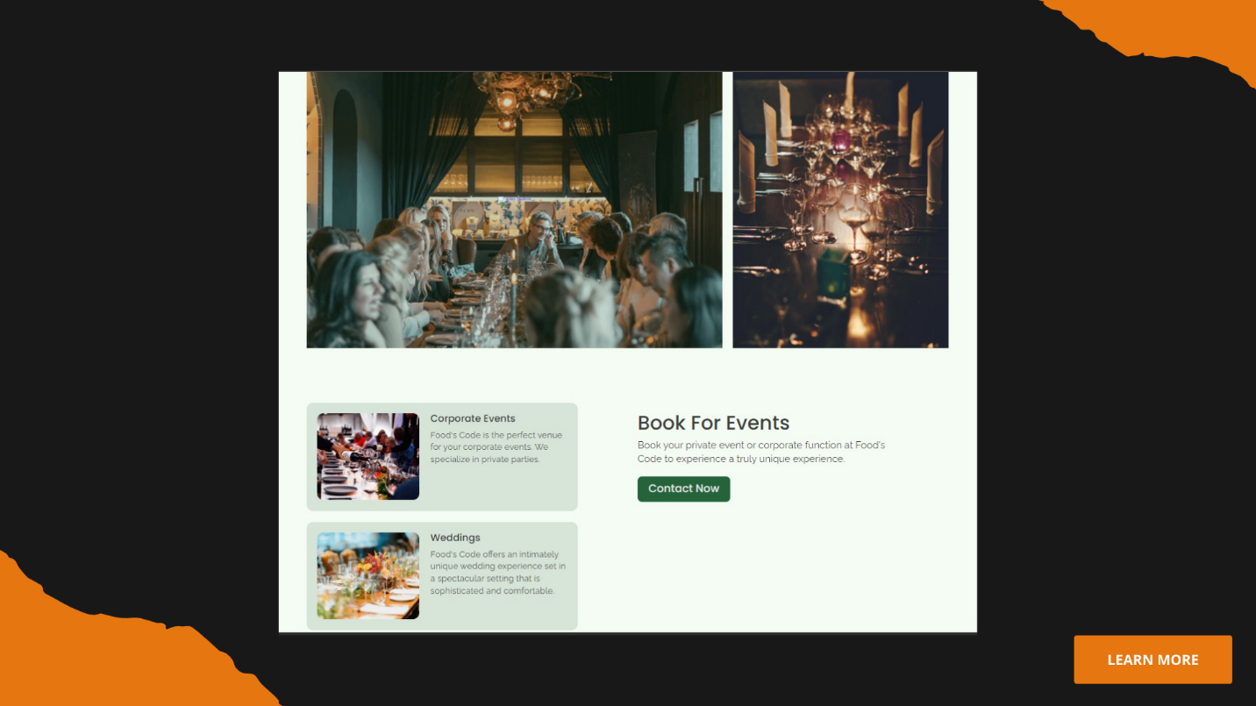

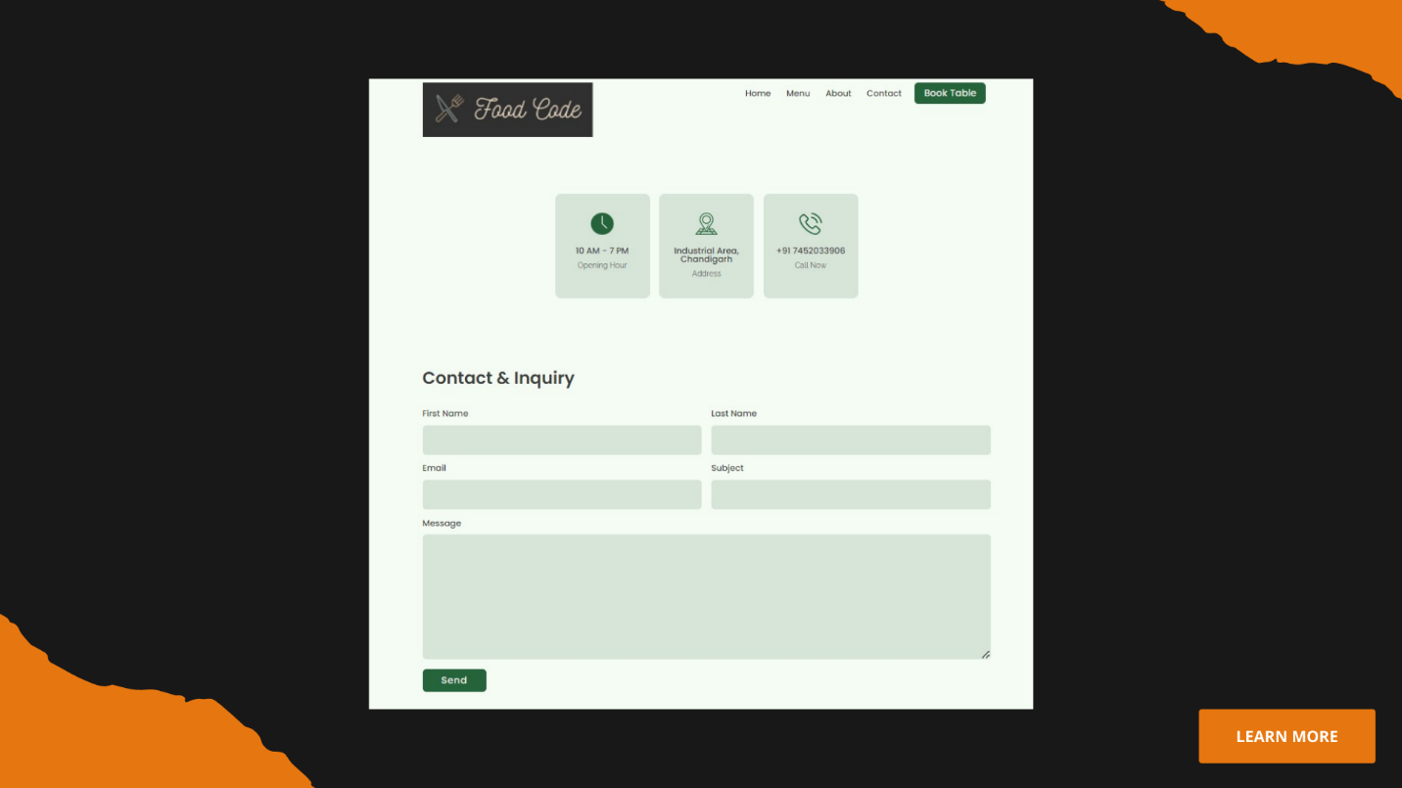

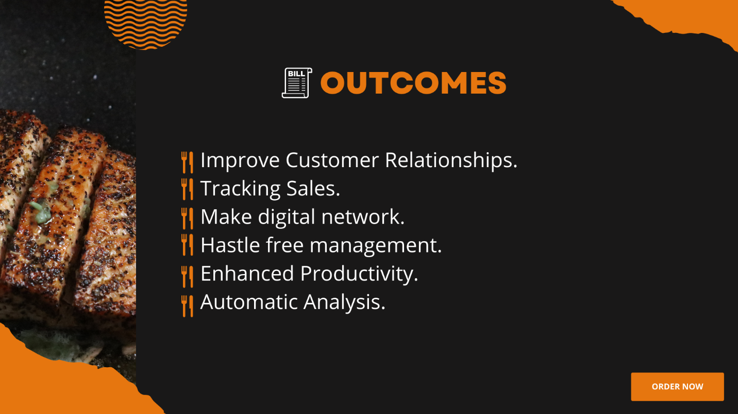

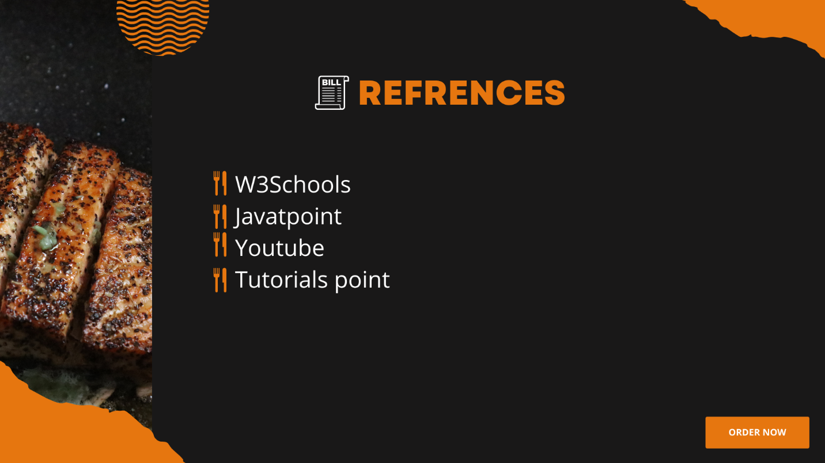

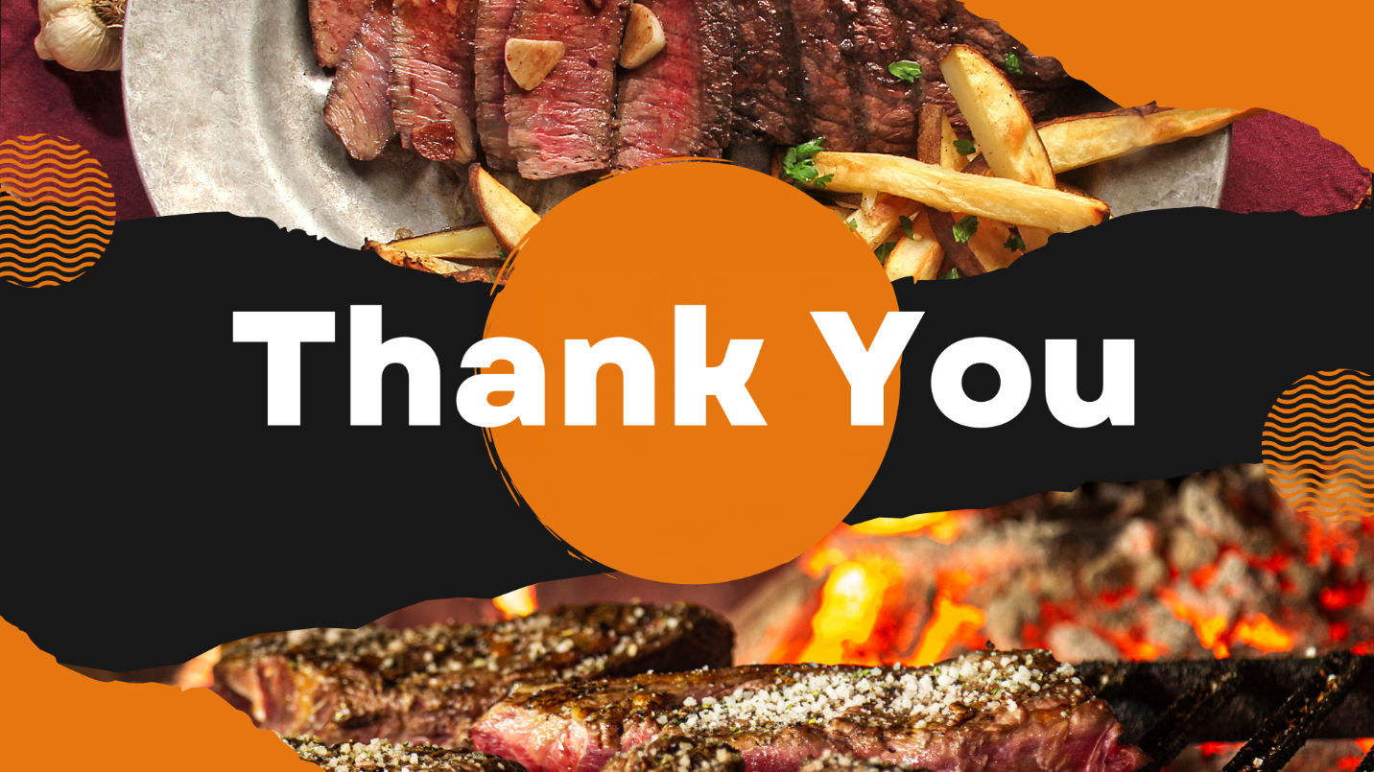

**Chapter – 4**

**ATTAINMENT OF STATED OUTCOMES**

The main outcome of this project is to manage the details of restaurants, sales, and meals. It manages all the information about the cafeteria, meal type, and meal. The purpose of the project is to build a website to reduce the manual work for managing the cafeteria. It tracks all the details about the sales, product, and meal.

There are the following outcomes that the project reach are:

* Improve Customer Relationships:

Well, the Food’s Code is designed on the basis of improving customer relationships. The website is very user friendly and very interactive. When any new user comes here he/she can easily handle or take their order in a few minutes at anytime and anywhere just pressing one click.

* Tracking Sales:

These days, the restaurants maintains a huge amount of credit card and cash transactions too. Therefore, this Food’s Code site helps to make life easy as the cafe manager by tracking all sales data using [Hybrid mobile app development](https://eibsglobal.com/hybrid-mobile-app-development/). With the help of this data, you will keep tabs on your items sold. This means Food’s Code also provides the power to make better decisions for your business.

* Automatic Analysis:

As a matter of fact, this Food’s Code software can automize the report generation. The site is designed in this way the admin can see all the reports of the café on their dashboard like the detail of products, cost, completed and progressed orders. In fact, it produces perfect reports on the impact of implemented marketing schemes like loyalty programs, and discounts, etc on consumer behavior. It helps the business to devise powerful future strategies to improve relationships with existing clients and get new ones.

* Enhanced Productivity:

The Food’s Code site all the products report to the admin. So this helps the admin to enhance productivity of the products very easily. So this is one of the most important outcomes of the Food’s Code.

**References**

Edition”, Canada, 1997.

* https://www.tutorialspoint.com/index.htm
* https://www.javatpoint.com
* https://www.w3schools.com
* https://html.co